I have used this GBI curriculum for quite some time and I am pretty certain I have done all the steps correctly leading up to Step 3 – Transfer Plan, but I am getting an error message when I try to transfer the SOP plan to demand management:

Here are screenshots of my SOP Plan:

FOR THE PG-BIKE060

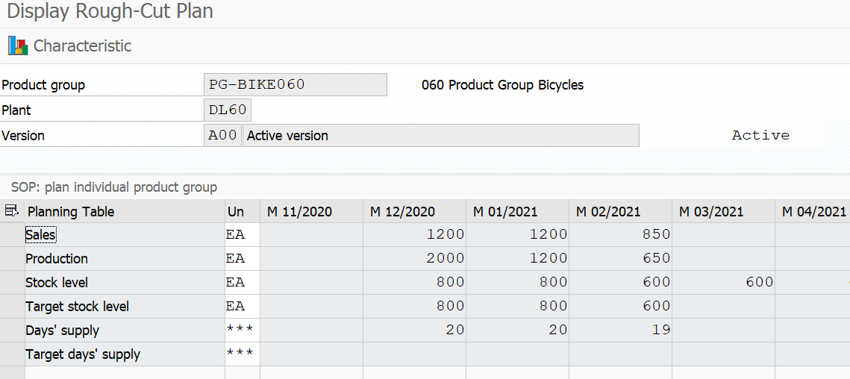

I disaggegated the plan and got all of the expected results. For example, here are the members of the PG-DXTR060 group after reaching the end of “Step 2: Disaggregate SOP Plan”:

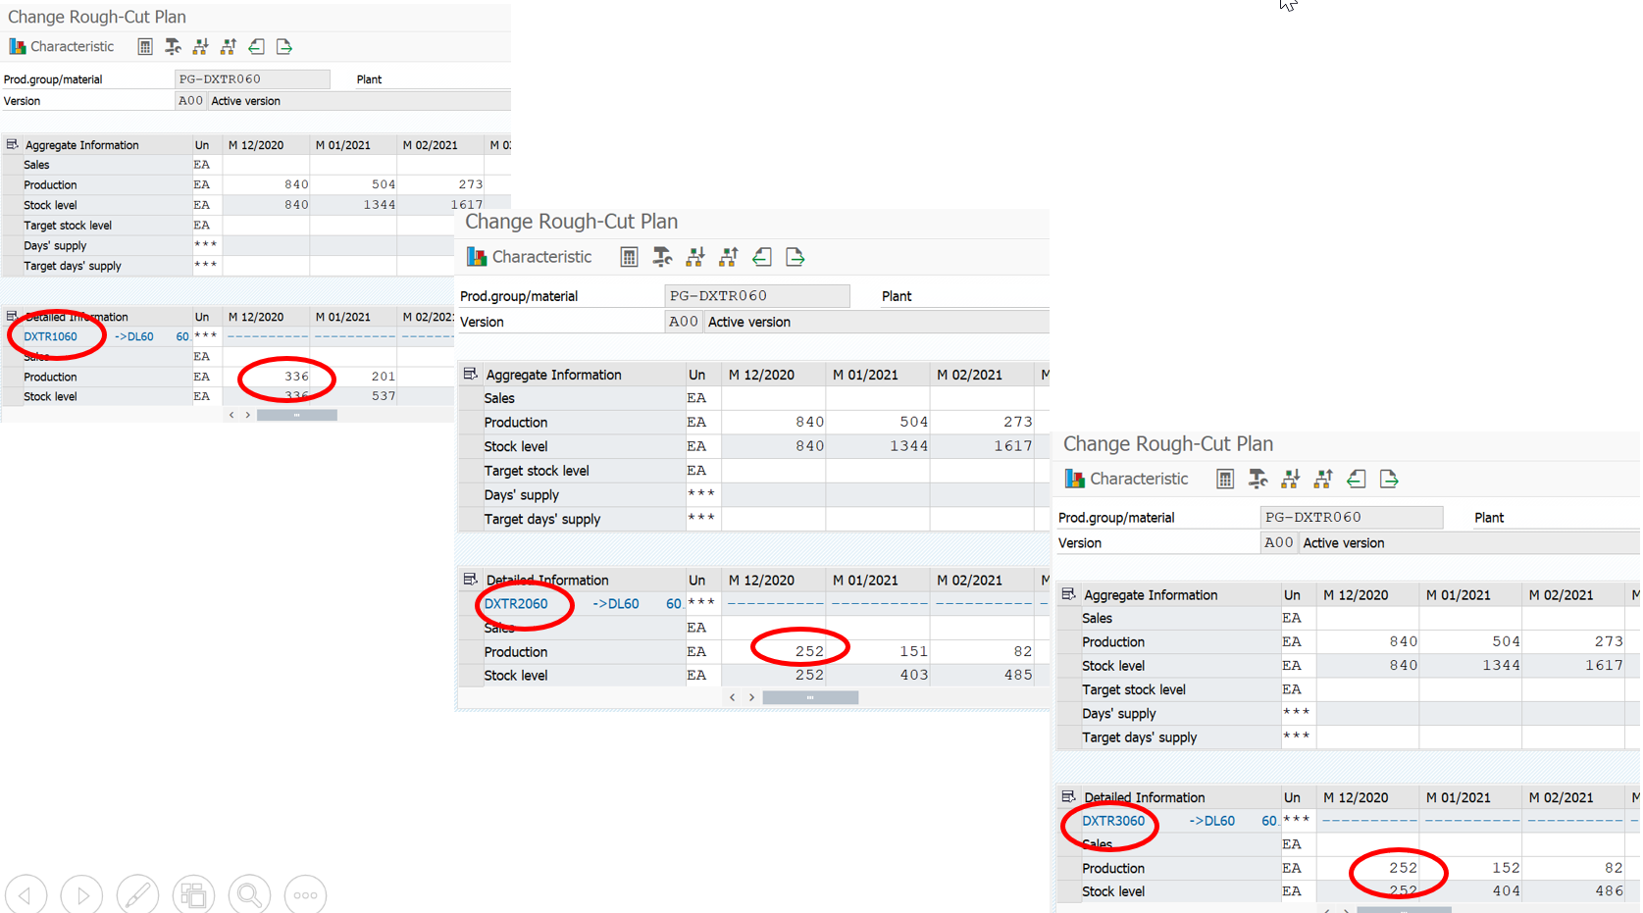

Notice all the “production” values are as expected.

But when I try step 3, Transfer Plan using these inputs:

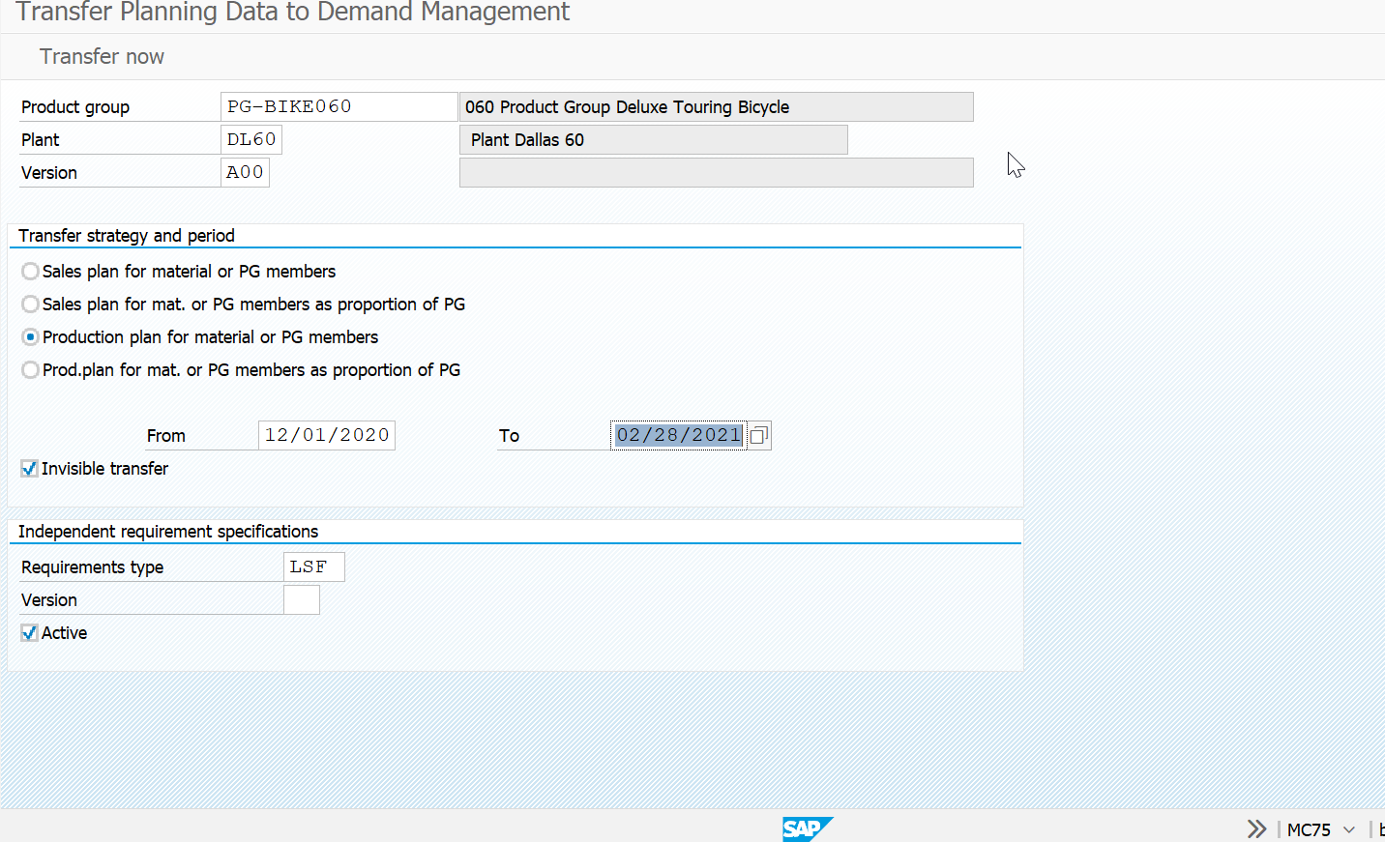

Here is the result when I use “transfer now”:

